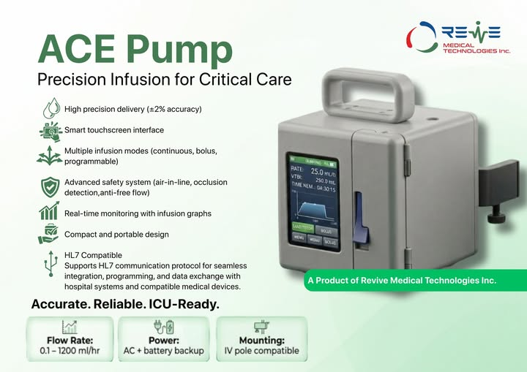
ACE Pump Precision Where Every Drop Matters.
Introducing the ACE Pump, an advanced infusion solution engineered for critical care environments where accuracy, safety, and reliability are essential. With high-precision drug delivery, intelligent touchscreen controls, multiple infusion modes, and real-time monitoring capabilities, ACE Pump empowers healthcare professionals to deliver optimal patient care with confidence. Designed for ICU readiness, portability, and seamless compatibility, it combines cutting-edge technology with user-focused functionality to support better clinical outcomes when every second counts.
#acepum #InfusionTechnology #CriticalCareVet #MedicalInnovation #healthcaretechnology #ReviveMedicalTechnologies #PatientSafety #MedTechInnovation
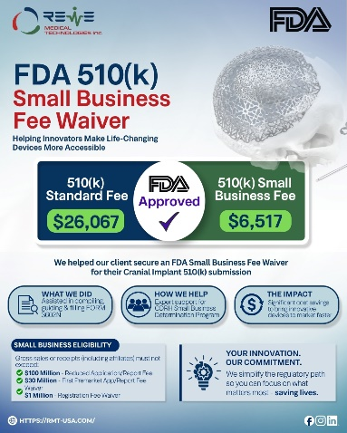
We at @revivemedicaltechnologies have been successful in obtaining an @fda Small Business Fee Waiver approval for our client’s 510(k) Cranial Implant submission. This reduced their FDA 510(k) user fee from $26,067 to just $6,517.
We assist in compiling, guiding, and completing FDA Form 3602N to help eligible businesses obtain Small Business Determination.
CDRH's Small Business Determination Program qualifies eligible businesses for reduced FDA user fees based on their annual gross sales or receipts.
Benefits include:
• Reduced Application Fee: Businesses (including affiliates) with gross sales or receipts of $100 million or less may qualify for reduced fees on eligible CDRH submissions.
• First Premarket Application/Report Fee Waiver: Businesses with gross sales or receipts of $30 million or less, including affiliates, may qualify for a waiver if neither they nor their affiliates have previously received this benefit.
• Registration Fee Waiver: Businesses with gross sales or receipts of $1 million or less may qualify for a registration fee waiver if they have previously paid the registration fee and can demonstrate financial hardship, subject to FDA eligibility requirements.
At Revive Medical Technologies, we provide end-to-end regulatory support to help medical device companies successfully navigate the FDA Small Business Determination process and reduce regulatory costs.
#ReviveMedicalTechnologies #FDA #FDA510k #medicaldevicesdevelopment #regulatoryaffairs #medicaldeviceregulations #cdrh #smallbusinessuk #FDAcompliance #medicaltechnology #HealthcareInnovation #regulatoryconsulting #qualityassurance #medicaldeviceindustry #innovations

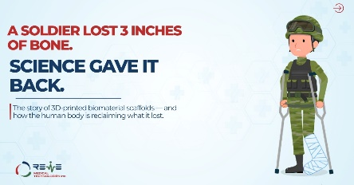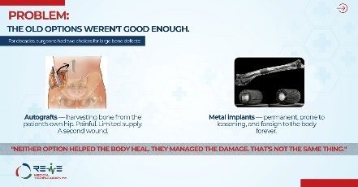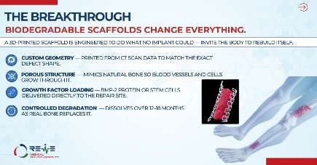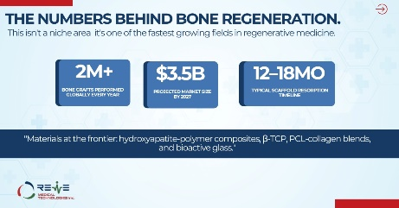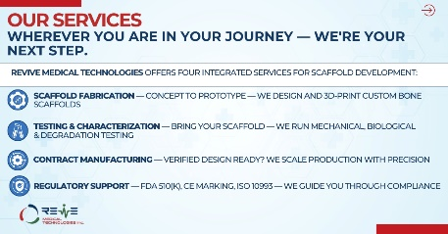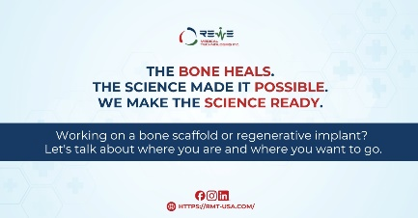
For decades, these injuries often meant multiple surgeries, long recovery times, and uncertain outcomes.Today, biomaterial science is changing that.3D-printed scaffolds are designed to do something remarkable—not replace bone permanently, but create a temporary framework that guides the body to regenerate its own tissue. As new bone forms, many scaffolds gradually degrade, leaving behind living tissue instead of permanent implants.It's a powerful example of how engineering and biology are beginning to work together rather than independently.In this carousel, we explore:
* Why critical-sized bone defects are so difficult to treat
* How biomaterial scaffolds support natural regeneration
* The science behind scaffold design and performance
* Why testing, manufacturing, and regulatory strategy matter before these technologies reach patients If you're working on the next breakthrough in biomaterials, Revive Medical Technologies Inc. can support you at every stage of the journey—from scaffold fabrication and material characterization to contract manufacturing and regulatory guidance. Whether you're a researcher, startup, or medical device company, we help turn innovative concepts into solutions that are ready for validation, scale, and clinical translation.
Science creates possibilities. Revive Medical Technologies Inc. helps bring them closer to patients.
Let's connect and discuss your project.
Phone: +1 (707) 5618 771
Email: info@rmt-usa.com
Website: https://rmt-usa.com/
Swipe through to discover how regenerative medicine is reshaping the future of bone healing.#ReviveMedicalTechnologies #biomaterials #tissueengineering #3dprinting #regenerativemedicine #biomedicalengineering #medicaldevices #boneregeneration #MedicalInnovation
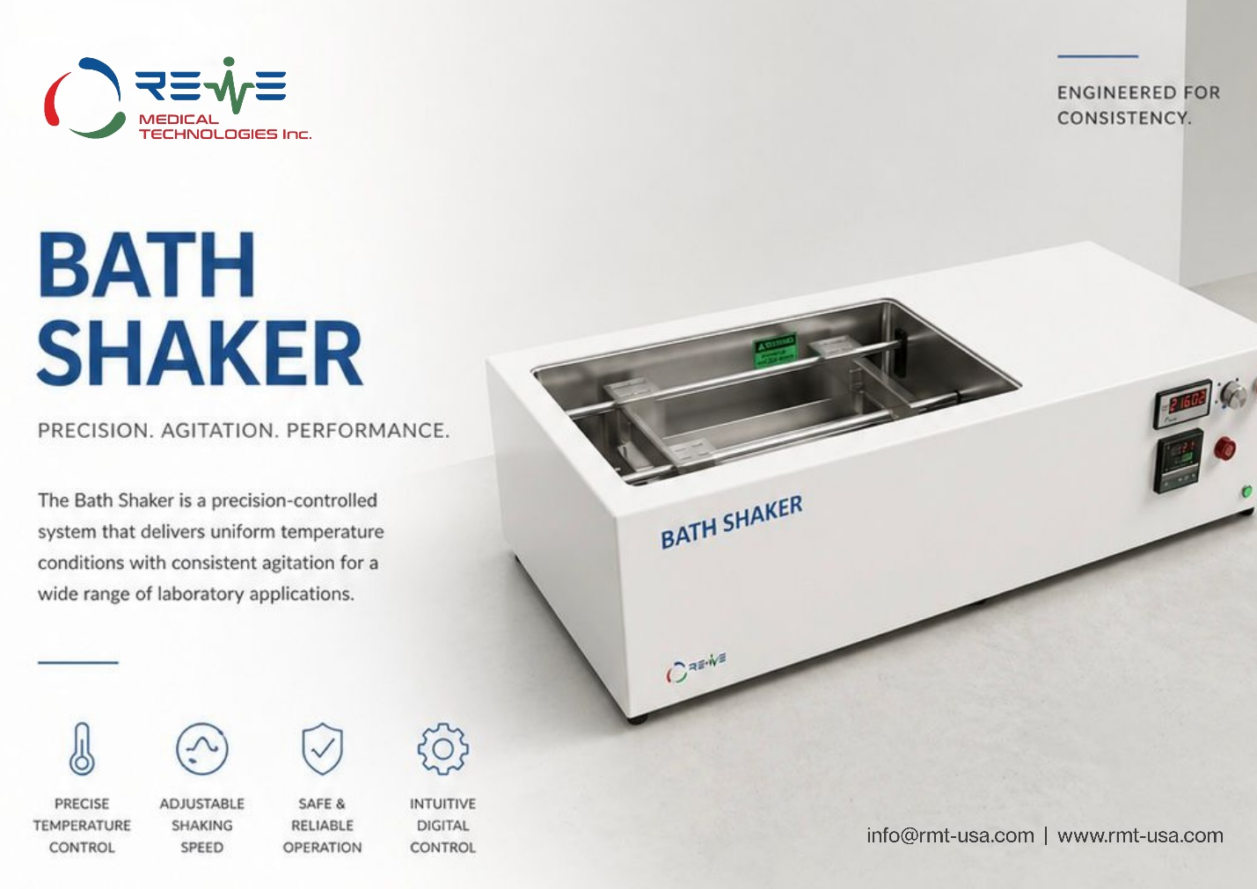
Revolutionize your laboratory testing with the advanced Bath Shaker by Revive Medical Technologies.
Engineered for consistency, this precision-controlled system delivers uniform temperature distribution along with consistent agitation, making it ideal for a wide range of lab applications. Featuring adjustable shaking speed, digital interface, corrosion-resistant chamber, and multiple safety protections, it ensures stable, low-noise, and reliable performance every time. Precision, agitation, and performance all in one powerful equipment.
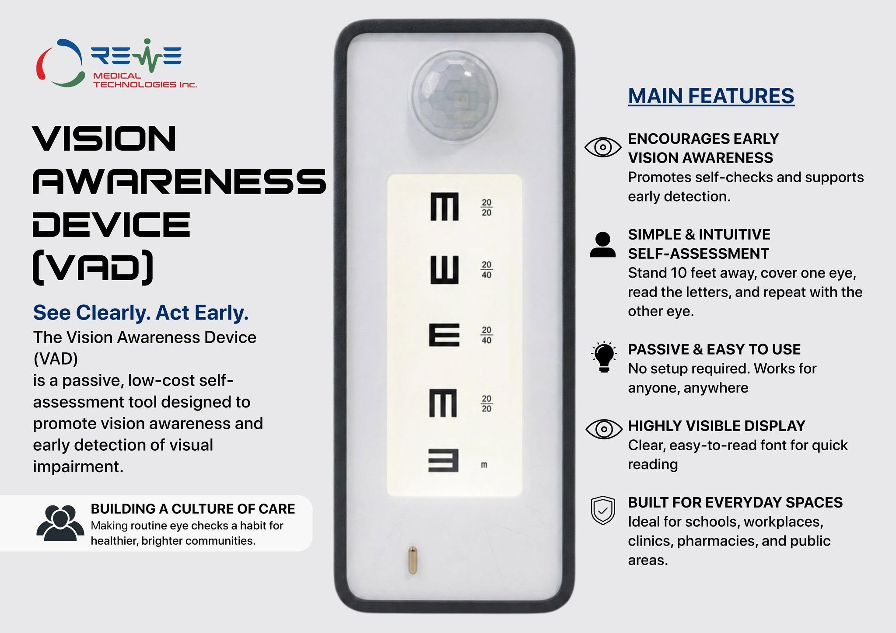
See clearly. Act early. The Vision Awareness Device (VAD) by Revive Medical Technologies is redefining how communities approach eye health making vision screening simple, accessible, and part of everyday life. Designed for effortless self-assessment, this passive and low-cost solution empowers individuals to detect potential vision issues early, without the need for clinical setup or supervision. From schools to workplaces and public spaces, VAD is more than a device it’s a step toward building a culture of proactive care, where awareness leads to timely action and healthier futures.
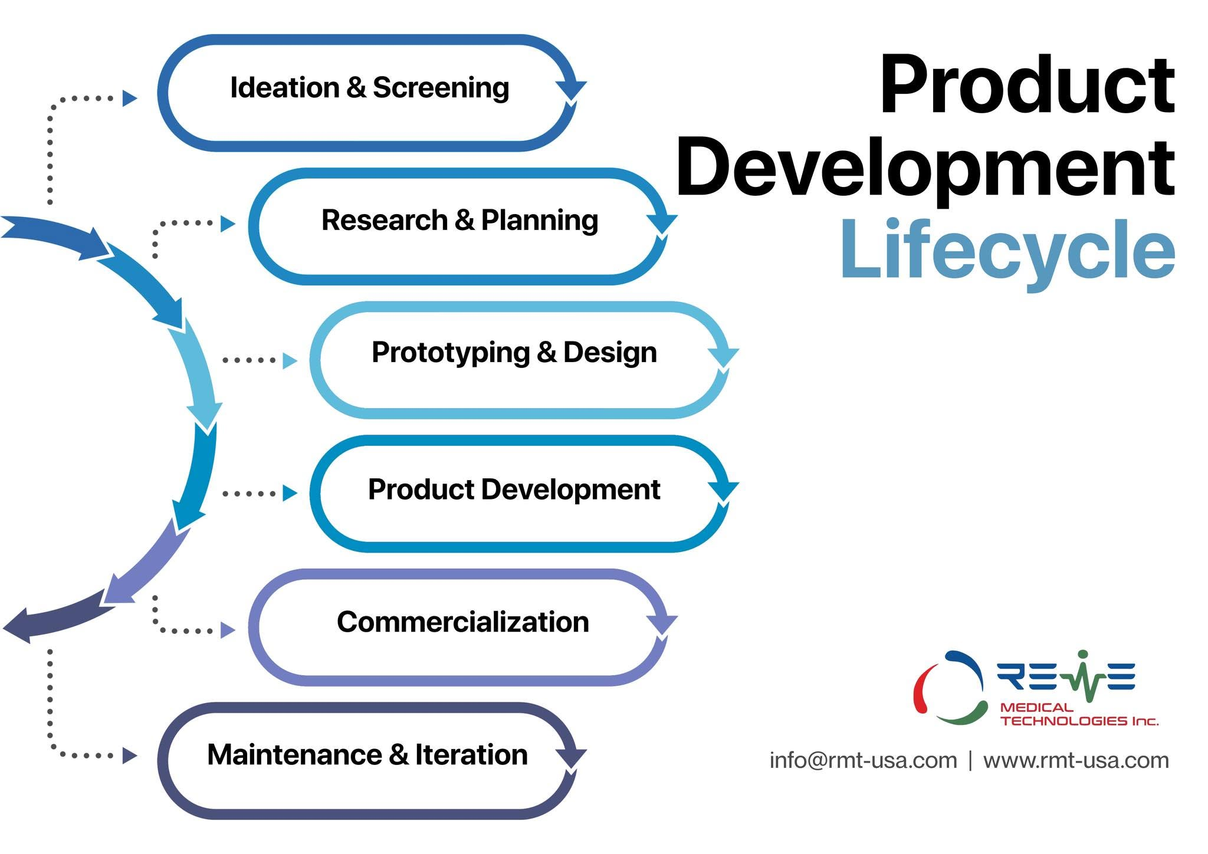
A robust Product Development Lifecycle is essential for ensuring safety, performance, and regulatory compliance in medical devices.
At Revive Medical Technologies Inc. our approach integrates structured planning, rigorous design validation, and continuous improvement aligned with global industry standards such as ISO 13485. From early-stage ideation and risk assessment to prototyping, testing, and commercialization, each phase is carefully managed to ensure both quality and reliability.
By combining engineering excellence with a strong quality-first mindset, we ensure that every product not only meets regulatory requirements but also delivers real clinical value.
Turning concepts into clinically reliable solutions step by step.
#medicaldevice #ISO13485 #QualityManagement #medtech

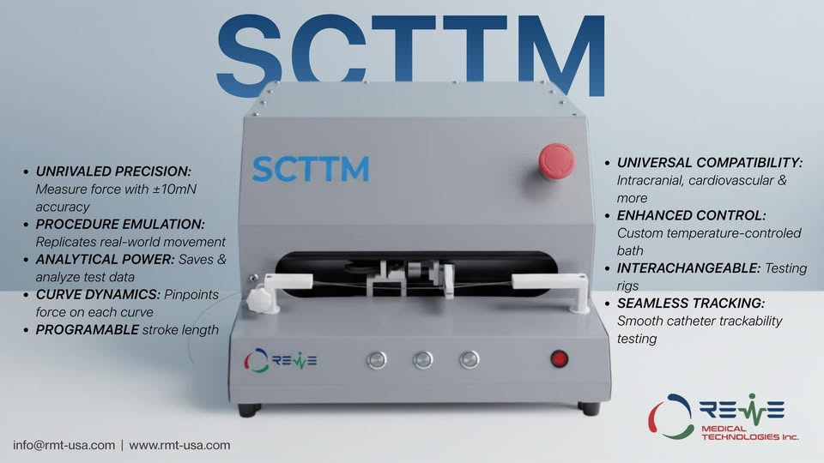
Introducing the SCTTM – the next-generation Specialised Catheter Trackability Testing Machine from Revive Medical Technologies Inc.Engineered for unrivaled precision and real-world procedure emulation, this cutting-edge system delivers exceptional performance for testing intracranial, cardiovascular catheters and beyond.
Key Highlights:
- Unrivaled Precision: Measures force with ±10mN accuracy (pinpointing force on each curve with curve dynamics)
- Procedure Emulation: Replicates real-world stroke movement length and movement
- Programmable stroke length for flexible, customizable testing
- Analytical Power: Saves & analyzes test data with powerful insights
- Universal Compatibility: Works with intracranial, cardiovascular catheters & more applications
- Enhanced Control: Custom temperature-controlled environment
- Interchangeable: Modular testing rigs for seamless adaptability
- Seamless Tracking: Smooth catheter trackability testing with seamless catheter tracking
Elevate your medical device testing with this advanced, temperature-controlled, interchangeable-rig system that offers unparalleled accuracy and control.Designed to emulate real-world conditions and provide detailed force dynamics analysis – the future of catheter trackability testing is here!Contact us today: info@rmt-usa.com | www.rmt-usa.com
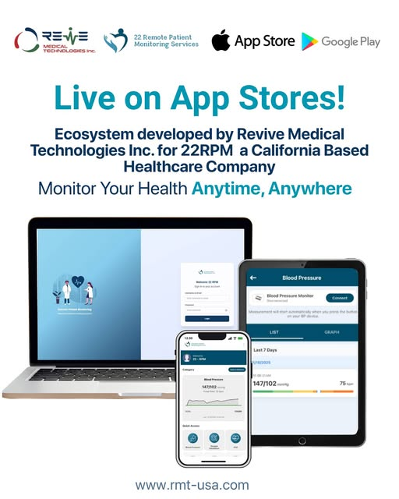
Big milestone for Revive Medical Technologies Inc.
We've successfully launched the 22-RPM Ecosystem now live on both Google Play and the Apple App Store
This complete Remote Patient Monitoring solution, built for a key client, features:
A real-time Web Dashboard for clinicians
An intuitive, secure Mobile App for patients
Months of hard work, innovation, and teamwork have turned complex healthcare needs into a reliable, scalable, patient-focused platform.
Proud to see both apps live a true testament to our HealthTech expertise.
Committed to building more solutions that empower providers, enhance outcomes, and drive digital healthcare forward.
On to the next launch!
Shoutout to practice owners in the US: ready to take your practice to the next level? Scale your care, streamline workflows, and increase your reimbursements with a customized RPM platform. Let's connect bdm@rmt-usa.com
#HealthTech #remotepatientmonitoring #DigitalHealth #HealthcareInnovation #ReviveMedicalTechnologies
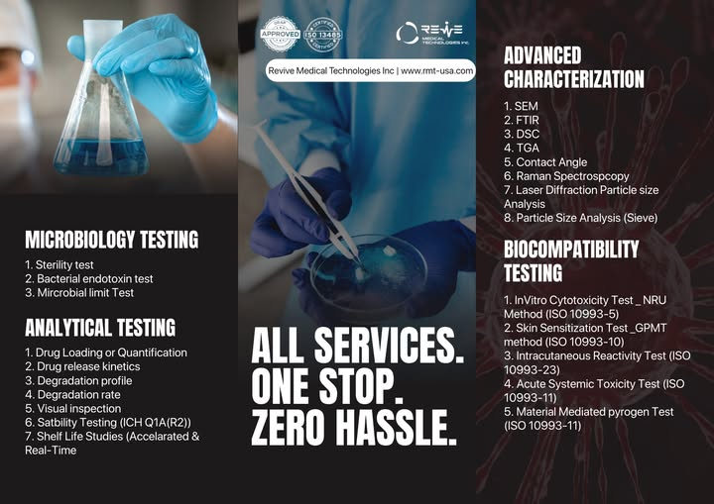Revive Medical Technologies Inc. is proud to offer comprehensive, reliable, and industry-compliant Testing services all under one roof. From Microbiology Testing and Analytical Evaluations to Advanced Characterization and Biocompatibility Assessments, we provide end-to-end solutions designed to ensure product safety, quality, and performance.
With ISO 13485 certification and a commitment to precision, innovation, and customer satisfaction, we help medical device manufacturers streamline their validation process with a true “One Stop, Zero Hassle” approach.
Partner with us to accelerate your product development and bring confidence to every result. Let Revive Medical Technologies be your trusted testing partner.
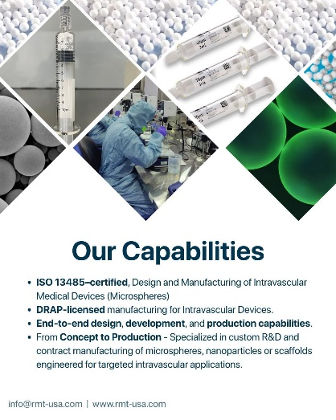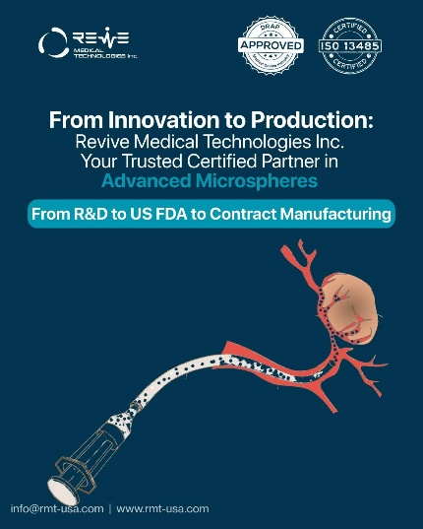
We are proud to announce that we have successfully completed the R&D of high-quality microspheres (an intravascular device) for vascular embolization application for our U.S.-based client and are now handling its US-FDA approval and offering them full-scale contract manufacturing at our both onshore and offshore production facilities. This milestone reflects our ability to translate complex innovation into reliable, scalable medical solutions.
Our capabilities are reinforced by our DRAP manufacturing license and ISO 13485–certified design and manufacturing scope for intravascular medical devices (microspheres), ensuring the highest standards of quality, safety, and regulatory compliance.
With this successful achievement, we now have the capacity to provide microspheres optimized for your intended applications, including:
-Embolization therapies
-Targeted drug delivery
-Controlled-release pharmaceutical formulations
-Interventional radiology and oncology procedures
Leveraging these capabilities, Revive Medical Technologies Inc. can offer:
-Custom microspheres tailored to your application
-Nanoparticles for advanced therapeutic delivery
-Polymer-based scaffolds for regenerative medicine applications
-R&D services to develop your intended formulations
-Contract manufacturing, delivering scalable, regulatory-compliant production
From innovation to commercialization, we are committed to delivering precision-engineered, high-quality medical products that meet the evolving needs of advanced therapies.
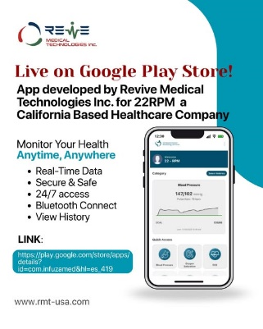
𝑴𝒊𝒍𝒆𝒔𝒕𝒐𝒏𝒆 𝑨𝒄𝒉𝒊𝒆𝒗𝒆𝒅: 𝑮𝒐𝒐𝒈𝒍𝒆 𝒑𝒍𝒂𝒚 𝒔𝒕𝒐𝒓𝒆 𝑨𝒑𝒑 𝒅𝒆𝒗𝒆𝒍𝒐𝒑𝒆𝒅 𝒃𝒚 𝑹𝒆𝒗𝒊𝒗𝒆 𝑴𝒆𝒅𝒊𝒄𝒂𝒍 𝑻𝒆𝒄𝒉𝒏𝒐𝒍𝒐𝒈𝒊𝒆𝒔 𝒇𝒐𝒓 𝟐𝟐𝑹𝑷𝑴 𝒂 𝒄𝒂𝒍𝒊𝒇𝒐𝒓𝒏𝒊𝒂 𝒃𝒂𝒔𝒆𝒅 𝒉𝒆𝒂𝒍𝒕𝒉𝒄𝒂𝒓𝒆 𝒄𝒐𝒎𝒑𝒂𝒏𝒚
Revive Medical Technologies Inc. software team has successfully developed and deployed Google play store App. Publishing a Remote Patient Monitoring (RPM) app in the healthcare category is no small feat and today, we’re thrilled to announce ours has successfully passed Google Play’s stringent requirements.
From medical device integration and secure patient vitals capture to clinician dashboards, AI Healthcare Agent insights, and strict compliance requirements, every phase from development to deployment comes with real technical, regulatory, and platform hurdles.
Healthcare software demands accuracy, reliability, privacy, and trust. Meeting Google Play healthcare policies while delivering a production-grade RPM solution is a challenge few truly understand until they’ve built one.
Proud of the Software Team Mr. Wajahat Mr. Amir Mr. Istafa and Mr. Umer at Revive Medical Technologies Inc. for turning complex healthcare concepts into a scalable, real-world product that clinicians and patients can trust.
This is just the beginning. Onward to advancing AI-powered remote care and enabling smarter clinical outcomes.
Want to see it in action? Check out the app here:
https://play.google.com/store/apps/details...
Interested in how we tackled compliance or AI integration? Ask in the comments!
#RemotePatientMonitoring #HealthcareTechnology #digitalhealth #HealthTech #AIinHealthcare #medicaldevices #GooglePlay #healthcaresoftware #productengineering #ReviveMedicalTechnologies
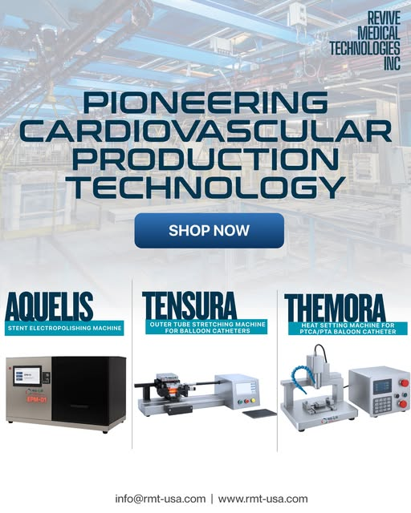
Revive Medical Technologies Inc. (RMT) boasts a distinguished legacy in the medical device industry, having pioneered proprietary production and testing equipment alongside specialized drug coating formulations. We take pride in establishing the first medical device industries in Pakistan and Saudi Arabia, dedicated to manufacturing high-quality, life-saving cardiovascular devices and implants. Our expertise extends beyond advanced process machinery and coatings to include extensive R&D in various materials and biomaterials used in intravascular devices and implants. At Revive Medical Technologies Inc., our scientific team is continuously focused on exploring innovative biomaterials and their biocompatible applications for a wide range of medical devices and implants.
#medicaldevices #biomaterials #cardiovasculardevices #medicalimplants #medtech #BiocompatibleMaterials #MedicalInnovation #healthcaretechnology #MedicalAesthetics #drugcoating #pakistanmedtech #saudiarabia #intravasculardevices #LifeSavingDevices

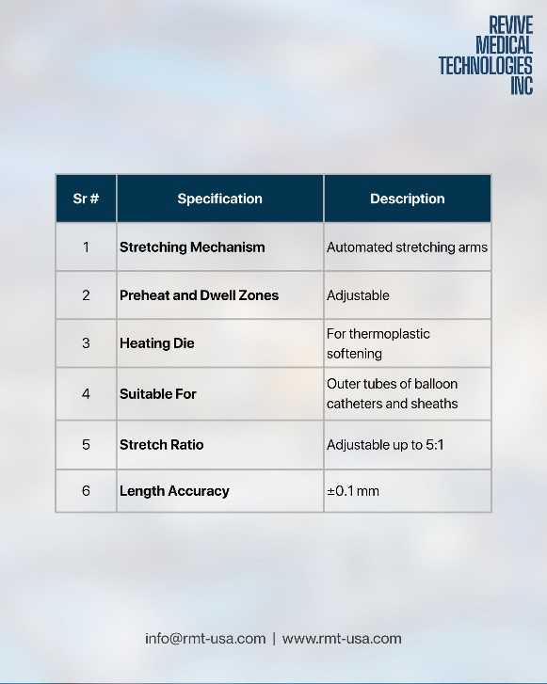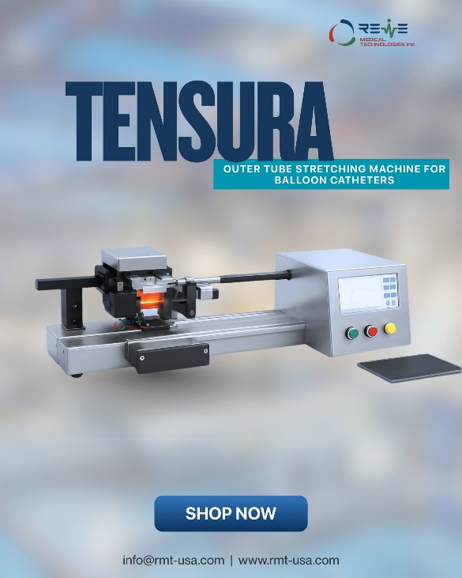
𝐓𝐞𝐧𝐬𝐮𝐫𝐚 – 𝐎𝐮𝐭𝐞𝐫 𝐓𝐮𝐛𝐞 𝐒𝐭𝐫𝐞𝐭𝐜𝐡𝐢𝐧𝐠 𝐌𝐚𝐜𝐡𝐢𝐧𝐞 𝐟𝐨𝐫 𝐁𝐚𝐥𝐥𝐨𝐨𝐧 𝐂𝐚𝐭𝐡𝐞𝐭𝐞𝐫𝐬
The Tensura Outer Tube Stretching Machine is a cutting-edge solution designed for precision manufacturing of balloon catheters and vascular sheaths. Engineered to enhance material properties like tensile strength and ensure superior diameter tolerances, Tensura delivers consistent, high-quality results critical for medical device production. With advanced temperature control and customizable parameters, it excels in tubing neck-down processes, adapting seamlessly to diverse manufacturing needs. Optional add-ons enable simultaneous processing of multiple tubes, optimizing throughput for scalable, high-volume production. Elevate your catheter manufacturing with unmatched precision and reliability.
#medicaldevices #cathetermanufacturing #PrecisionEngineering #MedTechInnovation #vascularhealth #ballooncatheters #biomedicalengineering #devicemanufacturin #healthcaretechnology #MedTechSolutions
#MedicalAesthetics #drugcoating #pakistanmedtech #saudiarabia #intravasculardevices #LifeSavingDevices
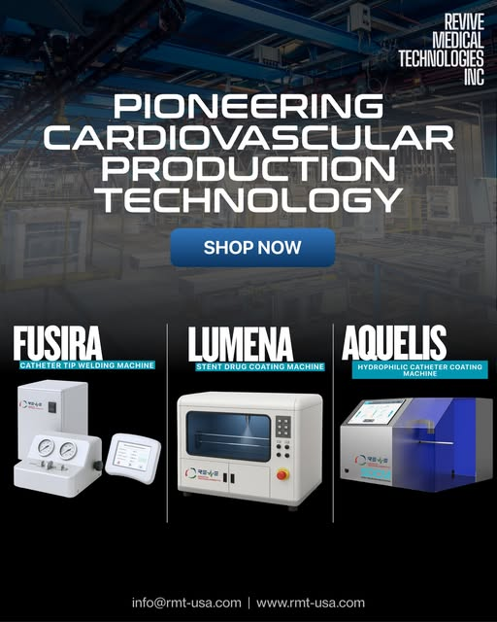
Revive Medical Technologies Inc. (RMT) possesses a notable history in the medical device sector, having developed its own proprietary production and testing machinery/equipment and drug coating recipes. We have successfully established Pakistan’s and Saudi Arabia’s first medical device industries for the production of good quality life-supporting cardiovascular devices and implants. We have the speciality not only on the process machines and coating recipes but we also have an extensive experience in the R&D of different materials/biomaterials which are being used in intravascular devices and implants. At Revive Medical Technologies Inc. our scientific community is always engaged in the research of new biomaterials and their biocompatible applications in different medical devices and implants.
#medicaldevices #biomaterials #cardiovasculardevice #medicalimplants #MedTech #BiocompatibleMaterials #MedicalInnovation #healthcaretechnology #medical #drugcoating #pakistanmedtech #saudiarabia #intravasculardevices #LifeSupportDevices

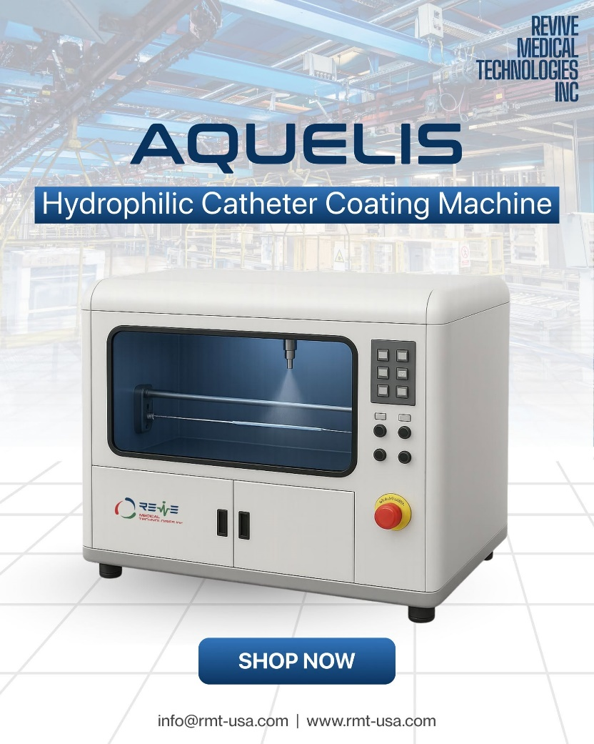
𝑨𝒒𝒖𝒆𝒍𝒊𝒔 – 𝑯𝒚𝒅𝒓𝒐𝒑𝒉𝒊𝒍𝒊𝒄 𝑷𝒐𝒍𝒚𝒎𝒆𝒓 𝑪𝒐𝒂𝒕𝒊𝒏𝒈 𝑴𝒂𝒄𝒉𝒊𝒏𝒆 𝒇𝒐𝒓 𝑷𝑻𝑪𝑨 & 𝑷𝑻𝑨 𝑩𝒂𝒍𝒍𝒐𝒐𝒏 𝑪𝒂𝒕𝒉𝒆𝒕𝒆𝒓𝒔
The Aquelis Hydrophilic Coating Machine is designed to apply precise, uniform hydrophilic coatings to balloon catheters, enhancing their trackability and performance during minimally invasive angioplasty procedures. It ensures smooth navigation through blood vessels by reducing friction, improving procedural safety and efficiency. The machine features automated controls for consistent coating application, meeting applicable international standards. It is designed to be used for medium to high throughput production setups.
Designed to bring unmatched precision and consistency to your processes and innovations
#HydrophilicCoating #medicaldevices #MedTechInnovation #devicemanufacturing #PrecisionEngineering #medicaltechnology #ReviveMedicalTechnologies #biomedicalengineering #NextGenMedicine #medicaldevicedevelopment #ResearchandInnovation #LabtoMarket #MedTechSolutions #HealthcareInnovation

